Jobayer Ahmed

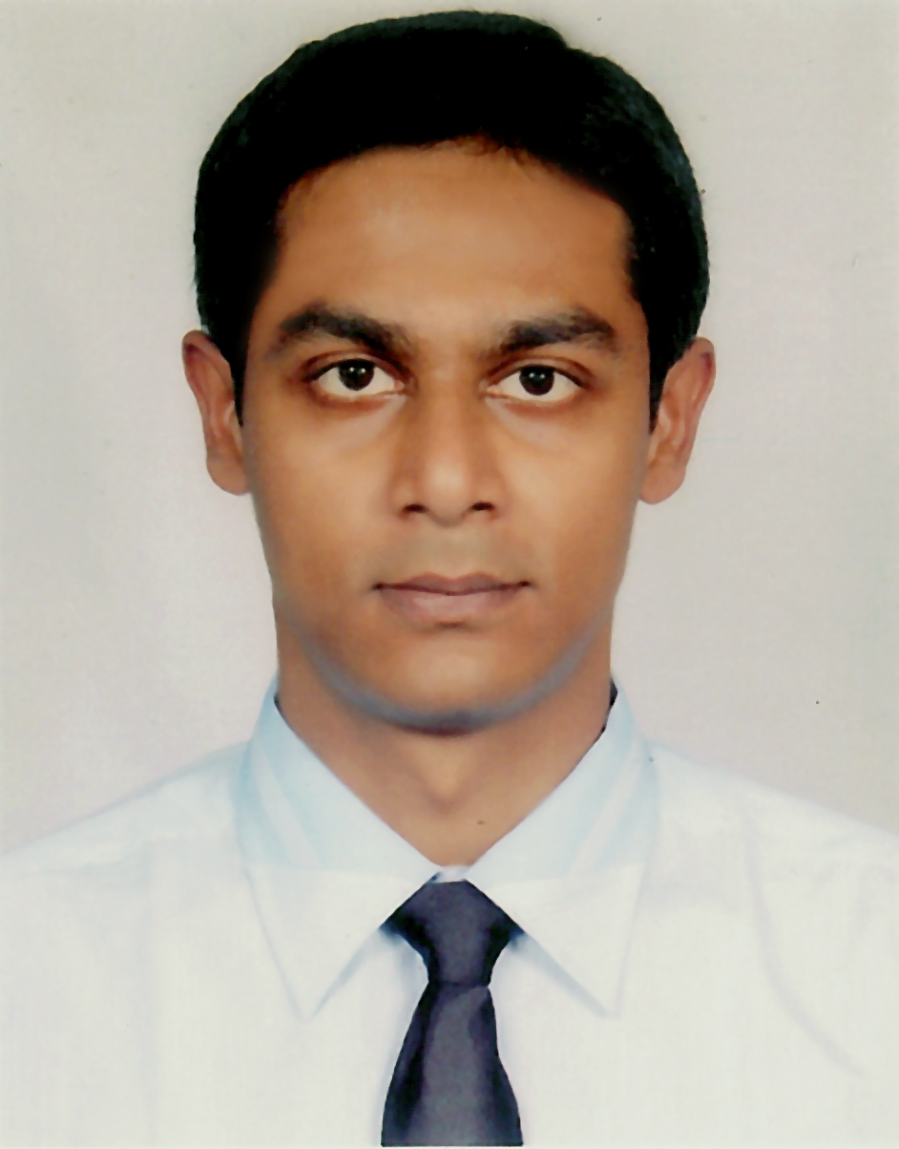

Aganagar, South Keranigonj,
Dhaka, Bangladesh
Cell Phone: +880 1777757284
E-mail: jahmed015@yahoo.com

Job Objective

To use educational skills to pursue a long term career in an organization, to significantly contribute to the confident progress of that organization.

Work Experience
Current Employment:
Working as Sub-Divisional Engineer at Power Grid Company of Bangladesh Ltd (PGCB) from 27th May 2012 till today.

Job Description
- Project Management of High Voltage Electrical Transmission Line (132kV & 230kV) construction project.
- Project Management of 132/33kV (4x50/75MVA) Electrical Grid Substation construction project.
- Entire management and supervision of Civil & Mechanical Construction & Erection Works.

Previous Employment:
- Worked as Assistant Engineer (Mechanical Maintenance) at Bangladesh Power Development Board (BPDB) from 12th December 2011 to 26th May 2012.

Job Description
- Mechanical maintenance of a Gas Turbine Combined Cycle Power Plant of 195MW generation capacity (GE Frame 9 machine with Mark 6 Control system).
- Attending plant scheduled outage (CI, HGPI, MI etc) and forced outage.
- Conducting workshop activities for casting, forming and machining mechanical spares.

- Worked as Assistant Engineer, Energypac Engineering Ltd., Tejgaon I/A, Dhaka from 17th August 2009 to 12th November 2011.

Job Description
- Project Management of Gopalganj 100MW Reciprocating Engine Type HFO Fired Power Plant construction project.

- Entire management and supervision of Mechanical Construction & Erection Works.

Educational Background

B. Sc.-Mechanical Engineering, 2009
Institute : Bangladesh University of Engineering & Technology, Dhaka.
Year of Passing : March 2009
Result : CGPA 3.52 (4 Point Scale)

Higher Secondary School Certificate, 2003

Institute : Notre Dame College, Dhaka.
Result : GPA 4.60 (5 Point Scale, without adding 4th subject)
Group : Science
Board : Dhaka.
Secondary School Certificate, 2001

Institute : S.M. Model Govt. High School, Gopalgonj.
Result : GPA 4.75 (5 Point Scale, without adding 4th subject)
Group : Science
Board : Dhaka.

Industrial Training

Holcim (Bangladesh) Ltd, Meghnaghat, Narayangonj.

Activities during training period:
- Field investigation on the Cement manufacturing Process.
- Case Study of the Production process.
- Case Study of the Maintenance process.
- Case Study of the Quality Control process.

Project & Thesis

“A Study on utilization and maintenance practices of Bio-medical instruments in hospitals of Dhaka city”

Under supervision of Prof. Dr. Md. Abdur Rashid Sarkar, Dept. of ME, BUET.

Language Proficiency

English : Fluent (both Written & Spoken)
Bengali : Fluent (both Written & Spoken)

Computer Skills

Programming in C & C++, Hardware assembling & troubleshooting, Operating systems (DOS, Windows 95, 98 & XP, Windows 2000 professional), Office Application (MS Access, MS Word, MS Excel, and MS Power Point) Photoshop and AutoCAD.

Achievements

- Attended & certified in a day long training program on Total Quality Management (TQM) by Prothom-alojobs on 22th January’10.

- Got 2 months long Basic Induction Training
By Bangladesh Power Development Board (BPDB).

Personal Information

Father’s Name : Saifuddin Ahmed
Mother’s Name : Ummey Habiba
Permanent Address : House No: 12, Imambari Road, Aganagar, South Keranigonj, Dhaka, Bangladesh.
Date of Birth : September 01, 1986
Marital Status : Single
Nationality : Bangladeshi
Religion : Islam

Reference
02.
Name : M.A.Ghani
Designation : Additional Chief Engineer
Organization : Public Work Department
(PWD)
Address : PWD Building, Ramna,
Dhaka
Relation : Familiar
Phone No : +8801199 843 445

01.
Name : Dr. Md. Abdur Rashid Sarkar
Designation : Professor of the Mechanical
Engineering Department
Organization :BUET
Address : ME Dept., 1st floor, EME building,
BUET
Relation : Academic
E-mail : rashid@me.buet.ac.bd

